

**North South University**

# Department of Electrical & Computer Engineering

**LAB REPORT**

Course Code: EEE141L

Course Title: Electrical Circuits I Lab

Course Instructor: Dr. Mohammad Abdul Matin (Mtn)

Experiment Number: 7

Experiment Name:

|  |
| --- |
| Charging and Discharging of RC circuits |

Experiment Date: 15/4/2021

Date of Submission: 21/4/2021

Section: 3

Submitted To: Tabia Hossain

|  |  |
| --- | --- |
| Submitted By | Score |
| Student Name and ID:  1. Md. Rifat Ahmed - 1931725042 |  |

**Objectives:**

• To learn about RC circuit.

• To observe the process of charging and discharging of the RC circuit with changing time.

• Verifying the charging and discharging properties of RC circuit.

**List of Equipment:**

• OrCAD Software

• PSpice Simulation Software

• 1 × 100Ω resistor

• 1 × 0.01F capacitor

• 1 × 100F capacitor

• Connecting wire

**Theory:**

**DC:**

When an electric charge flows in a constant direction and does not vary with time then it is called Direct current (DC). And as it flows in a constant direction it does not have any frequency which means its frequency is zero.

**AC:**

A current that varies sinusoidally with time is called Alternating current (AC). As it changes with time its frequency can be found from its time period (T).

**Capacitor:**

An electric component that stores electric charge is called Capacitor.

Capacitor Construction:A capacitor is made using 2 close plates that are separated by a dielectric material, which is a poor conductor or sometimes an insulator.

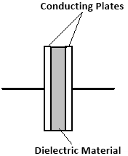

When the two conducting plates are connected to power supply an electric field is generated between the plates making one plate positively charged and the other negatively charged. And a capacitors relation with charge and potential difference can be denoted as,

C = $\frac{Q}{V}$

And the capacitance of a capacitor is the amount of charge stored in the capacitor per unit voltage and its unit is Farad. Capacitance is denoted as,

XC =

Where, w is the angular frequency = 2πf. So, here if f was 0 then that would mean the angular frequency is 0 then,

XC = = = ∞

And the capacitor is open circuit in DC circuits and short circuit in AC circuits. That’s why we’ll be using AC source for this experiment.

**Time Period:**

The time required for a current to complete 1 cycle is called time period. And the relation between time period and frequency is, T = $\frac{1}{f}$

**Frequency:**

The number of cycles completed in a second is called frequency. Frequency is denoted by, f = $\frac{1}{T}$

**Time Varying Signal:**

A signal whose values changes with time. There could be three types of signal Sin wave, Square wave and Triangular Wave.

We can generate these signals using a device called signal generator.

Here’s what a square wave looks like:



Where, V0 is the maximum voltage of amplitude and T is the time period of the signal.

**Peak Voltage:**

The maximum voltage of a signal is called the peak voltage and it’s denoted by VP.

**RC Charging:**

A circuit made of a resistor and a capacitor is called a RC circuit.

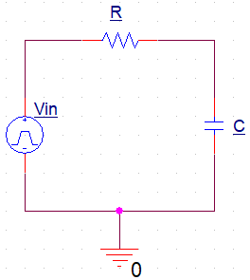

In a circuit when the input is positive the capacitor will charge gradually through the resistor until the voltage across the capacitor equals the supply voltage.

Here, the amount of time required for the capacitor to fully charge is equivalent to 5 time constants or 5[𝜏.](https://www.compart.com/en/unicode/U+1D70F)

And Voltage, VC across the capacitor varies with time according to the formula,

VC(t) = V0 (1 – e–t/RC)

Where, V0 is the amplitude of the input signal and RC is the time constant which is also denoted by 𝜏.

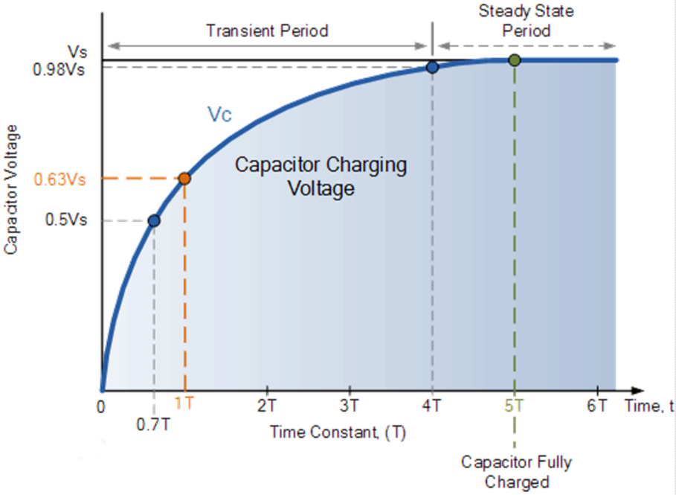

Figure: Capacitor Charging Graph

**RC Discharging:**

If the input signal becomes negative the capacitor starts discharging itself back through the resistor. And for a discharging circuit the voltage across the capacitor, VC with respect to time is defined as,

VC(t) = V0 e–t/RC

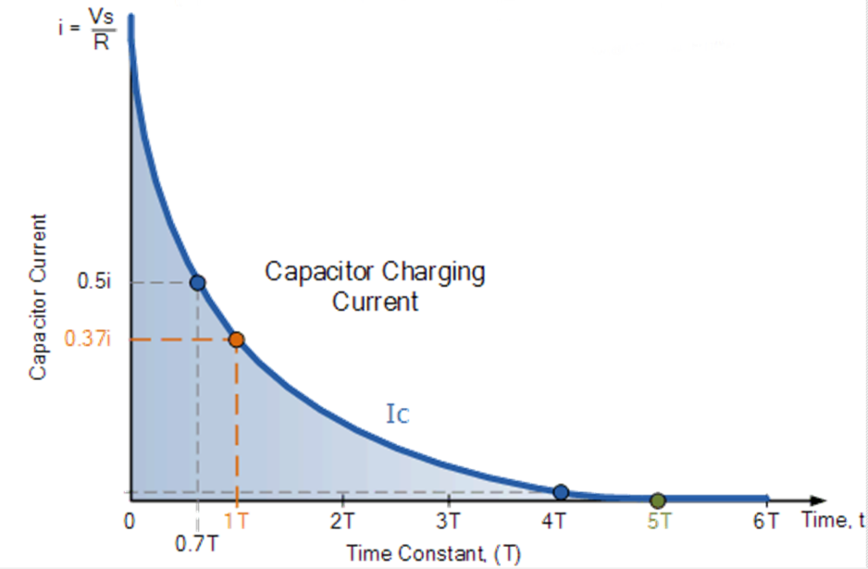

Figure: Capacitor Discharging Graph

Now if combine both Charging and Discharging graph, we can get the full charging-discharging graph of a capacitor.

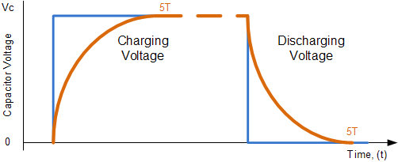

Figure: Capacitor Charging-Discharging Graph

**Circuit Diagram:**

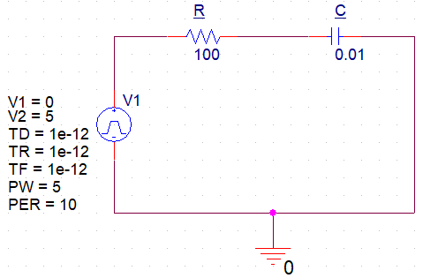

**Circuit – 1**

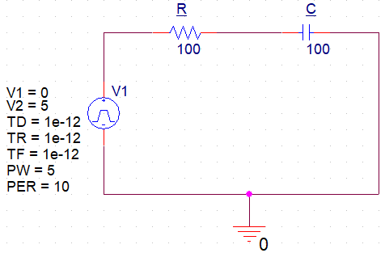

**Circuit – 2**

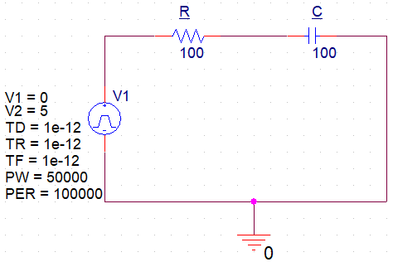

**Circuit – 3**

**Data Sheet:**

**Input-Output graph of Circuit 1:**

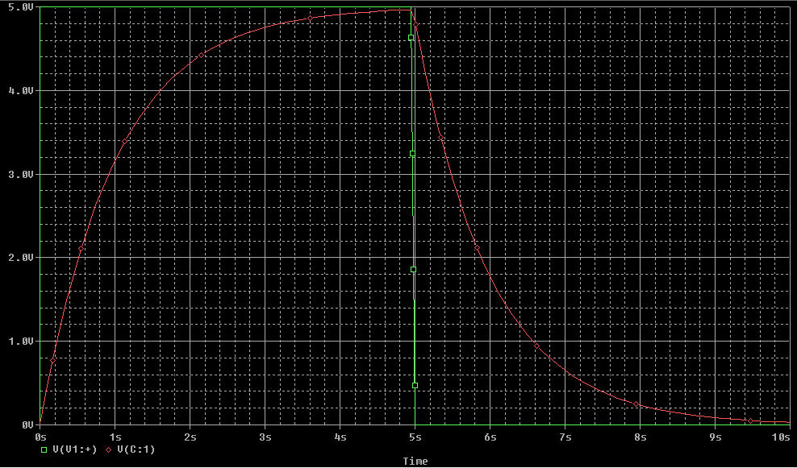

**Input-Output graph of Circuit 2:**

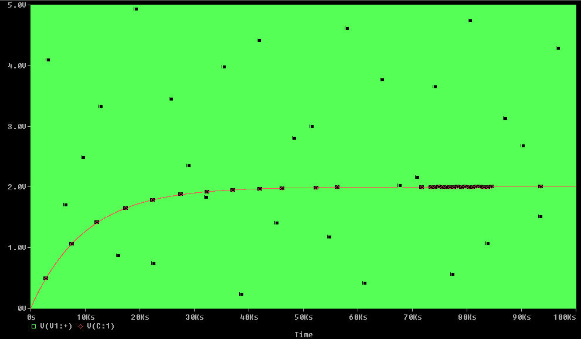

**Input-Output graph of Circuit 3:**

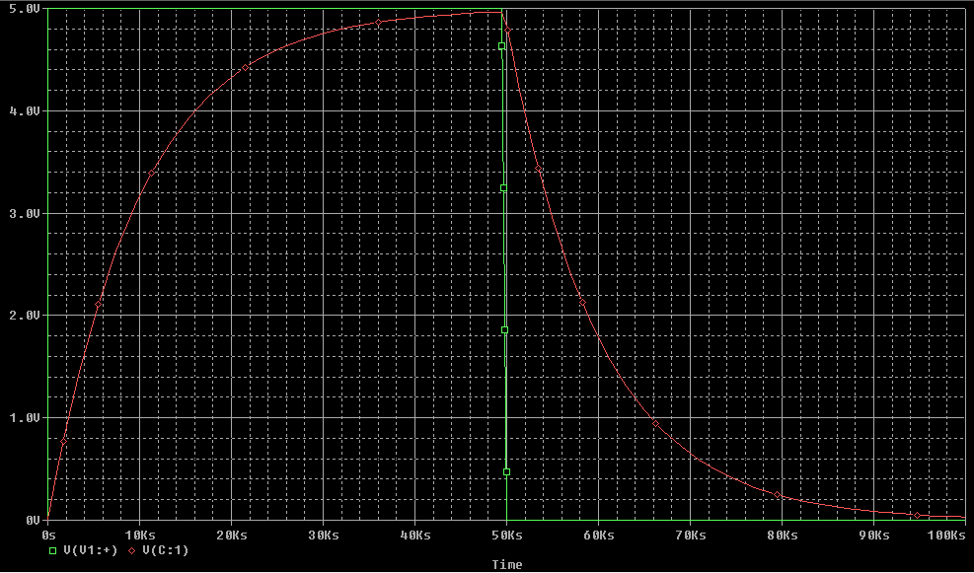

**Result Analysis & Discussion:**

From this experiment we’ve learned about ac, dc, capacitor we also learnt about different types of time varying signals and then we learnt about the charging and discharging process of RC circuits and we verified them using the simulation graphs.

For circuit – 1 we took a 100Ω resistor and a 0.01F capacitor. So, the runtime used for it was 10T = 10 RC = 10 × 100 × 0.01 = 10 second and in this circuit the pulse width, PW was 5 and the pulse width rate, PER was 10 so the runtime was equal to the PER. And for that we got the correct input-output graph of charging discharging.

Then for circuit – 2 we took a 100Ω resistor and a 100F capacitor. So, the runtime used for it was 10T = 10 RC = 10 × 100 × 100 = 100000 second. However, in this circuit the pulse width, PW was 5 and the pulse width rate, PER was 10 which was way much smaller than the runtime. And that’s why we got the wrong input-output graph of charging discharging for circuit – 2.

Which is why we modified circuit – 2 so that we could get the correct charging discharging graph. So, now for circuit – 3 we again took a 100Ω resistor and a 100F capacitor then we took the pulse width, PW as half of our runtime which is 50000 and pulse width rate, PER equal to the runtime which is 100000. And then we got the correct input-output graph of charging discharging for circuit – 3 which was the modified version of circuit – 2.

And no during this experiment we didn’t face any problem as everything was very clear and understandable during the class.